**STM32F407G-DISC1 Board-Main Controller**

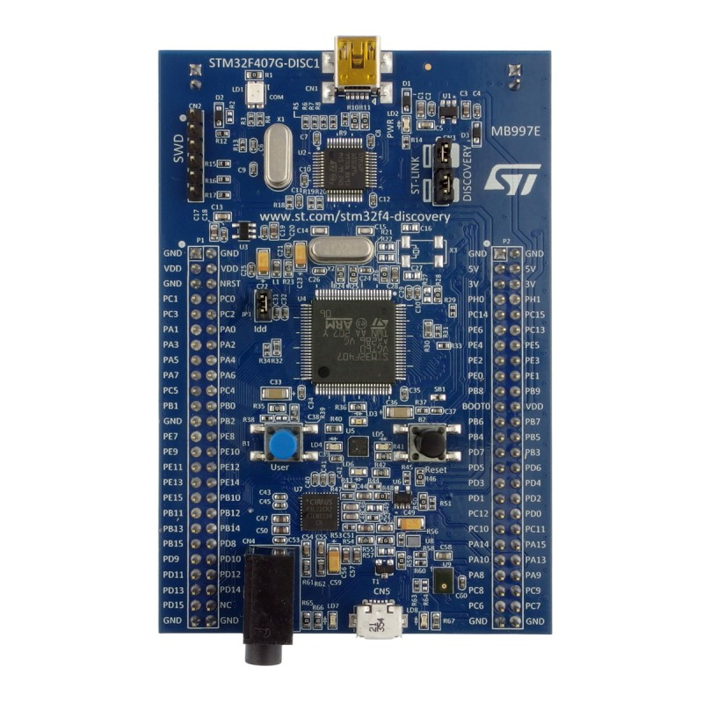

**1.Details**

**Name**: STM32F407G-DISC.

**Manufacturer**: STMicroelectronics.

**Microcontroller**: STM32F407VG(ARM Cortex-M4, 32 bit MCU).

**Purpose in your project**: “Acts as the main controller to collect sensor data,and integrate the data, for the user.

**Operating Voltage**: 3.3 v - 5.0 v.

**2.Features**

i.Stm32 is a 32 bit microcontroller.

ii. 1 MB Flash memory and 192 KB SRAM.

iii. Micro-AB connector USB interface.

iv. Sensor: 3-axis accelerometer.

v.Headphone output jack.

Vi. 4/2 USART/UART, 3 SPI, 3 I2C, 2 CAN.

vii.User interface

1 Reset button, 1 User button, 4 LED’s(green,blue,red,orange).

viii.Software & Development Tools: STM32CubeIDE,etc.

ix.9 I/O ports (A to I).

x.Architecture:-ARM Cortex-M4 32bit RISC core

xi.Operating Frequency:-168MHz.

xii.ADC:- 3 12 bit ADCs.

xiii.DAC:-2 12 bit DACs.

**3.Pin configuration**

Power Pins:

-3v3:-power output, 5v:-power output,VBAT:-Backup power,VDD:-Main MCU Power,GND:-Ground.

-All remaining GPIO pins can be used as digital input/output.

Communication Pins: different pins for each protocol.

-PA0:-User button.

-PD12:-Green.

-PD13:-Orange.

-PD14:-Red.

-PD15:-Blue.

**4.Test Code**

LED blink code to test proper working of Stm32 Board

#include <stdint.h>

#include <stdio.h>

#include"stm32f407xx.h"

#define BV(n) (1 << (n))

#if !defined(__SOFT_FP__) && defined(__ARM_FP)

#warning "FPU is not initialized, but the project is compiling for an FPU. Please initialize the FPU before use."

#endif

void led_init(void);

void led_on(void);

void led_off(void);

int main(void)

{

led_init();

while(1)

{

led_on();

DelayMs(1000);

led_off();

DelayMs(1000);

}

}

void led_init(void)

{

//0. enable clock for GPIOD in AHB1

RCC->AHB1ENR |= BV(3);

//1. select mode as output

GPIOD->MODER &= ~(BV(25) | BV(27) | BV(29) | BV(31));

GPIOD->MODER |= BV(24) | BV(26) | BV(28) | BV(30);

//2. select type as push pull

GPIOD->OTYPER &= ~(BV(12) | BV(13) | BV(14) | BV(15));

//3. select speed as low

GPIOD->OSPEEDR &= ~(BV(25) | BV(27) | BV(29) | BV(31));

GPIOD->OSPEEDR &= ~(BV(24) | BV(26) | BV(28) | BV(30));

//4. select pull up/down as no

GPIOD->PUPDR &= ~(BV(25) | BV(27) | BV(29) | BV(31));

GPIOD->PUPDR &= ~(BV(24) | BV(26) | BV(28) | BV(30));

}

void led_on(void)

{

GPIOD->ODR |= BV(12)| BV(13) | BV(14) | BV(15);

}

void led_off(void)

{

GPIOD->ODR &= ~(BV(12)| BV(13) | BV(14) | BV(15));

}